1.Day Trading Basics
https://jyotibansalanalysis.com/


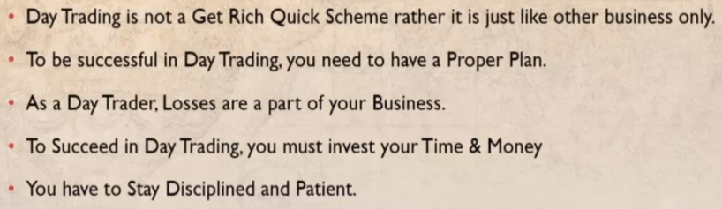





They accept that each trade has a pre-determined level of risk and they follow the rules they set for that trade. Nobody wants to lose but the best traders are the great losers. They accept their losses and move on to the next street.

if you want to be a successful day trader. The other things like how to manage that is how to choose the right stock how to identify potential entry point and how to exit from the trade.

Pros & Cons of Day Trading
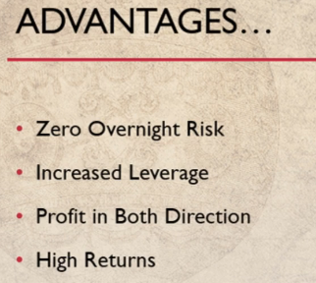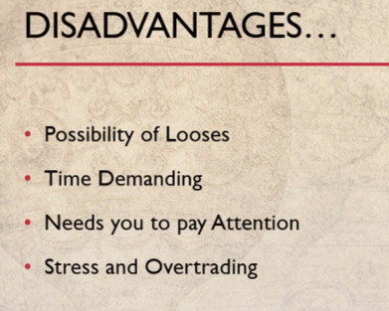

Zero overnight risks is one of the best advantages of day trading is that our day trader can close his trade at or before the end of trading day.
So the news and events that affect the next trading days opening do not affect the portfolio and risks of holding a stock overnight are erased

In other types of trading your profits can disappear overnight but with day trading your profits are secure as long as you are holding your position before the end of the trading session.

For example on 26th July Facebook made our downfall of approximately 20 percent overnight. And at the next day Facebook price was 20 percent down in just a single night. In traditional trading

You would have high levels of investments to put up in the market but in day trading
You need to put up less money to get profits because of low margin requirements for day trades.
So this increased leverage can multiply your profit.

In day trading we can make profit in both the directions. In long term investment
You keep invested your stocks for a long time only in the current rent
but day trader can take advantage of both Rising and falling markets in a single day.

A day trader can
make profits by trading momentum by trading in the rising market.
But a day trader can also short-sell the stock in falling market
by adopting some strategies thus have the ability to lock in profits even as markets are struggling with a bad news and fall throughout the day.

If you employ the strategies properly and manage your position sizing your rewards as a day trader can far exceeds the risk.
It doesn't mean that you will get high returns all the time.
In the beginning you have to learn the in's and out's of the market but over time it follow the art with discipline you will learn this skill very effectively.

Day trading requires discipline and time management but it also offer a trader to make his own hours set for trading without organizing a staff or a boss standing over back.
Day trading can make form of comfort of your own home.

There are also some disadvantages associated with day trading. The first and the big disadvantage of day trading is possibility of large losses. Day trading is an aggressive type of trading and can be very risky.
Not being able to manage the losses is the biggest reason of failing in day trading so a day trader shouldn't risk the money that he cannot afford to lose.

You should know about the proper risk management that we will learn in our next lecture.
Losses are the part of day trading so You need to learn how to take a loss.
Nobody makes money every day.
In the beginning stage many day trader suffer weird losses in the first months of the trading and couldn’t stay in the process long enough to see the profit.

So I will recommend to always paper trade in real simulated accounts for at least two months before getting with your real money.
The second disadvantage of day trading is that it requires a lot of time and attention paid to the market.
You should have the knowledge of trends, technical indicators and the news regarding the market.
A lot of time is needed to study outside of your trading hours. Day trading is a high demanding profession
In this course we will know how to find out the stocks having important news.

Stress is a routine part of day trading
Tracking various movements in just a few minutes creates a lot of stress.
And because of this traders generally get involved in overtrading
But if you trust on your knowledge and analysis and manage your trades properly you will not make this kind of mistake.

Types of Day Trading



There are four types of day trading scalping, fading, momentum trading and support and resistance trading.
All the four types of day trading are different from one another
hence strategies are different for each type.


Scalping is one of the most popular type of day trading Scalping is focusing on taking small profits on small price change
It requires a lot of stamina because so many trades need to be ordered and exited quickly.
It also requires a stiff and aggressive exit strategy because one large loss could wipe out the several small realized profits.
In scalping it is important to make small amounts of money from a large amount of trade.
In scalping you must need to read your self of the let your profit run mentality.
You will get into and out of positions according to your trading signal only.


Fading is where we trade against the prevailing trend.
In fading we can short the stock after a rapid move in upward direction.
Though fading involves a considerable amount of risk but It is also more profitable when market is overboard or oversold early traders are ready to begin taking profits.
Therefore, price moves in opposite direction fading strategies are also considered as a reversal strategy.
How to trade the reversal strategies that we will learn later in the course.


Momentum trading is one of the most important type of trading. In momentum trading our traders joins the move when the stock price is picking up.

This type of trading involves trading on news releases and on high volume. Momentum trading is the best type of trading and also my favorite.

The common risk reward ratio in momentum strategy is 1:2 but it can reach up to 1:4 in most of the cases.


Trading support and resistance levels is a type of day trading involves
Profiting from a stocks daily volatility.
This is done by buying the stock at the low of the day if any support level is near to it
And selling at the high of the day at resistance level that is near to the high of the day.

Support and resistance levels can be traded by looking at the higher timeframe chart
And that is 15 minute chart and we have to keep an eye on support and resistance levels of about 3 to 4 months of trading history Support and resistance levels are formed when a stock repeated touches a price level and unable to break it.

In downside it is a support level and in upside it is at a resistance level and we can trade these levels if we are able to find out them effectively.

As we know if a resistance level is broken upward, it becomes our support level and if our support level is broken downside, it becomes our resistance level.

So on the break out we can make a position in the same direction of the trend.
and if prices respect the level and remain range won't we can make a trade in counter trend direction.

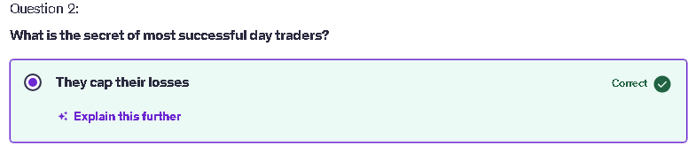
You selected "They cap their losses" because successful day traders implement strict measures to limit potential losses on their trades, which helps to protect their capital and maintain long-term profitability. This approach is essential in managing risk and ensures they can continue trading even after facing losses.

